Minutes FOR Common Council Tuesday, August 20, 2024

Call to Order, Pledge of Allegiance, Roll Call
The meeting was called to order by Mayor Paul Dwyer at 6:00 p.m. After the Pledge of Allegiance, roll call was taken. Present: Paul Dwyer, Travis Scholze (remote), Richard Yarrington, Shawn Zabinski, John Glynn, Nicole Hart (remote, then arrived at the meeting in person at 6:25 p.m.), Patrick Devine, Nelly Pater, and Dean Peterson. Absent: none. Also present: Kirk Arity, Becki Weyer, Jeremy Likely, Adam Robarge, Irma Keller, and Pam Buchda. The meeting was available via Zoom and was recorded by Hagen Sports Network. All motions are unanimously approved unless otherwise noted.

Adjourn to Closed Session Pursuant to Wis Stat § 19.85 (g) to Confer with Legal Counsel for the governmental body who is rendering oral or written advice concerning strategy to be adopted by the body with respect to litigation in which it is or is likely to become involved
Motion by Peterson, second by Yarrington, to adjourn to closed session pursuant to Wis Stat § 19.85(g) as stated above. Motion carried.

Council adjourned to closed session at 6:03 p.m. The Council remained in Chambers with the City Attorney; all others were asked to leave the meeting.

The meeting resumed to open session at 6:56 p.m.

ANYONE DESIRING TO APPEAR TO COUNCIL
John Glynn invited everyone to the flag raising ceremony at Cardinal Glass on October 4th to celebrate the achievement of an important level of OSHA certification.

Mayor
The Mayor did not give a report.

Monthly SET Report
The Senior Executive Team provided a monthly written report and Arity provided a summary for the Council.

Public Safety July Monthly Report
Chief Adler provided a monthly written report.
Fire: Jeremy Likely appeared to give highlights of the fire report and answer any questions from the Council.
EMS: Adam Robarge appeared to give a summary of the EMS report and answer any questions from the Council.

Tomah Area Ambulance MOU with the updated Stipend changes
The MOU updates the chart and pay for off-duty transfers to the following:
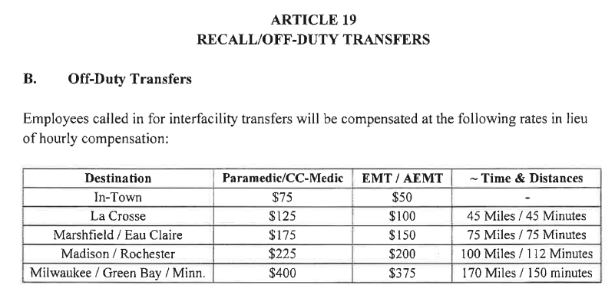
Motion by Scholze, second by Yarrington, to approve the MOU as presented. Motion carried.

Library
Dir. Keller covered the checkouts from the library over the last month and the upcoming scheduled events. Details can be found at tomahpubliclibrary.org.

Senior & Disabled Services Department Monthly Report
Buchda provided a monthly written report and covered the highlights with the Council. She directed anyone who would like a booth at the craft fair to contact her; it will be held during opening weekend of deer hunting.

Permits and Code Enforcement Reports
Casey Kinnear submitted monthly permits and code enforcement reports.

Motion to Reconsider Reinstatement of City Administrator by Alderperson Patrick Devine
Patrick Devine Alderperson made a motion for the Council to reconsider the motion for reinstatement of the City Administrator made at the July Council meeting. Nellie Pater seconded this. Scholze brought up the fact that the motion to reconsider is improper due to the fact that actions, money, and contracts have been signed after the motion was passed. Role call vote: Travis Scholze, no, Richard Yarrington, no, Shawn Zabinski, Yes, John Glynn, No, Nicole Hart, yes, Patrick Devine, yes, Nellie Pater, Yes, Dean Peterson, No. The Mayor broke the tie with a yes vote. The motion is reconsidered. Point of order by Travis Scholze that discussion of a City Administrator was not on the agenda and should not be discussed. The City Attorney suggested that the agenda item as written has alerted the public about the topic to be discussed. Motion by Pater, second by Zabinski, to reinstate the City Administrator and to create a committee to produce a job description, pay grade salary, and to bring it back to the Council. The Council members again had a lengthy discussion of the merits of a City Administrator vs. the current Senior Executive Team. Pater asked to withdraw her motion, Zabinski withdrew her second. Motion by Pater, second by Zabinski to form a committee to research having a City Administrator position, with a job description and salary and bring back to council. It was discussed that if formed, the committee should weigh the pros and cons of the City Administrator position vs. the current SET that is in place. Pater declined to amend her motion.

The Mayor recognized Irma Keller, and she asked if the Council would consider asking other department heads on said committee if it is formed.

The Mayor recognized Mike Kelly to speak. He made a comment asking if the Council has done a more extensive review of each department to see what problems exist and where a City Administrator could improve things.

Scholze asked for the makeup of the committee and if the committee would be ad hoc and the mayor and Pater opined that yes, it would.

Yarrington called the question to have a vote on moving forward without further discussion. Motion passes with no negative vote.

The vote was called. Roll call vote was called: Yarrington: No. Scholze, No: Zabinski, yes, Glynn: no, Hart: No, Devine: No, Pater: Yes, Peterson: No. Motion failed with six negative votes.

Motion by Glynn, second by Yarrington to form an ad hoc committee to investigate the possibility to create a city administrator position. The committee shall define the job description, the pay range, and the pros and cons of the existence of a position compared to the SET and would indicate where the money will come from in the budget. The mayor called a vote. Motion carried with one negative vote. (Scholze.)

The mayor called a short break at 8:30p.m.

Discussion on dates/availability for Elected Official Training - Alderperson John Glynn
There will be a training event for council members and any commission/committee member who wishes to attend. Glynn asked the Council members for their availability over the next month to get dates when everyone would be able to attend the planned training. September 18th, October 2nd, and October 9th, at 6:00p.m. were discussed as potential dates. The finalized date and time will be shared with other committee members. Council asked the cost of the training, and the clerk said it would be approximately $2500.

CONSENT AGENDA:
Motion by Peterson, second by Zabinski, to approve the following consent agenda:
A. Approval of Minutes from July 16, 2024
B. Appointment of 2024-2025 Election Officials
C. Special Beer and Wine Permit Application by Tomah Rotary Club for Neighborhood Block Party on September 13-14, 2024
D. Application of “Class A” Liquor, Class “A” Fermented Malt Beverage Licenses and Renewal of Class “B” Fermented Malt Beverage Licenses and “Class C” Wine Beverage License
E. Approval of Airport Hangar No. 11 lease transfer from Mark Kenworthy to Susan Kenworthy in the lease between City of Tomah and Mark Kenworthy
Motion carried.

Amendment of Ordinance Section 30-48(A)(B) First Reading, Second Reading, Adoption
Motion by Yarrington, second by Zabinski, to waive the first verbatim reading of the Ordinance amending ordinance Section 30-48(a)(b) of the City of Tomah Municipal Code. Motion carried

Motion by Peterson, second by Zabinski, to waive the second verbatim reading of the Ordinance amending ordinance Section 30-48(a)(b) of the City of Tomah Municipal Code. Motion carried

Motion by Peterson, second by Yarrington, to adopt the Ordinance amending ordinance Section 30-48(a)(b) of the City of Tomah Municipal Code. Motion carried

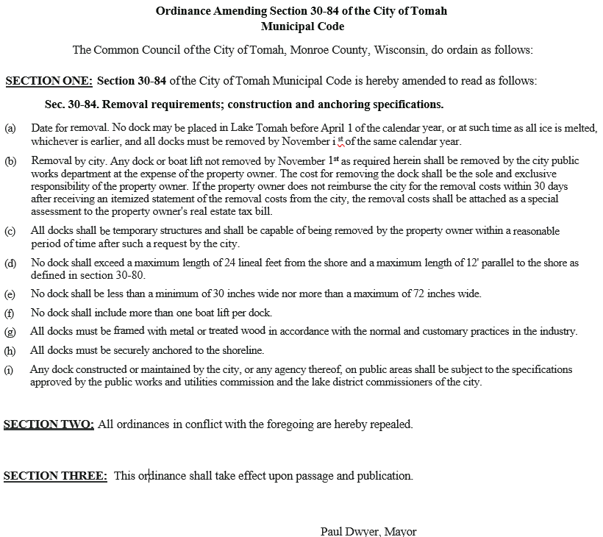
Approval of vacation and sick leave pre approval for external Sergeant candidates
Motion by Zabinski, second by Glynn to approve the vacation and sick leave for external Sergeant candidates if needed. Motion carried.

Resolution approval to petition WI DOT for state and federal aid at Bloyer Field
Motion by Yarrington, second by Peterson, to approve the resolution for approval to petition the WI DOT for state and Federal aid at Bloyer Field. Motion carried.
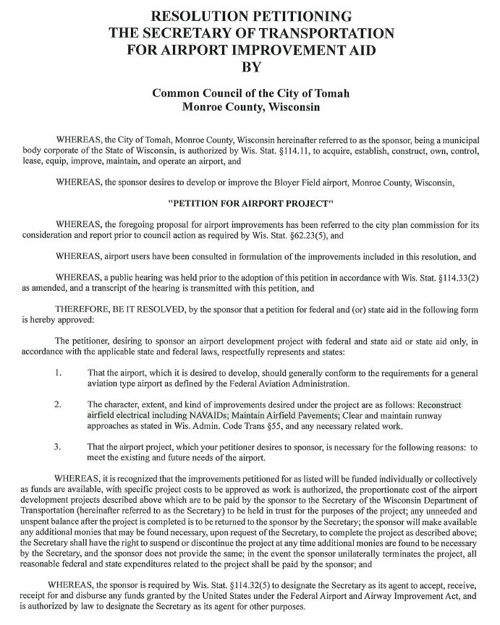
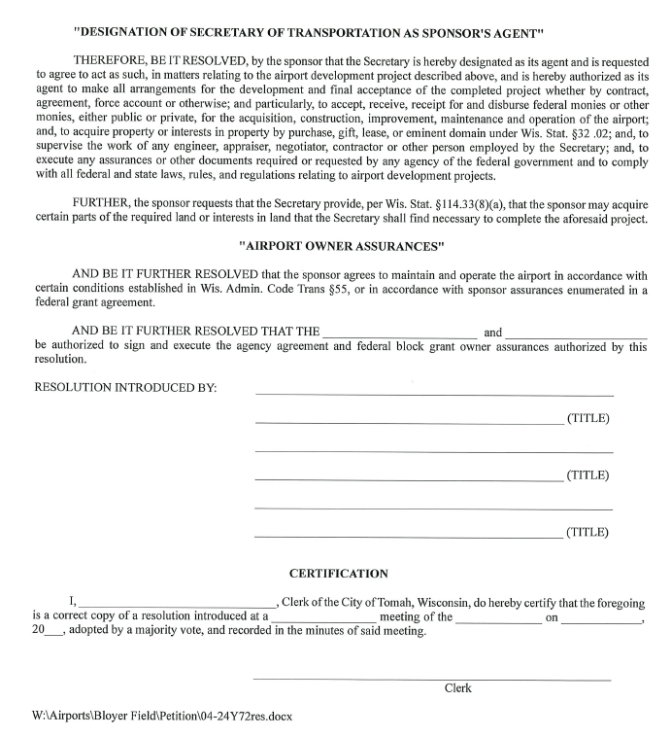

Approval of agreement for 823 W. Veterans St.
Motion by Peterson, second by Zabinski, to approve the easement agreement between the City of Tomah and the owners of 823 W. Veterans St. Motion carried.

Ordinance amendment approval - Sec 10-37 (Permit Fee Schedule)
Motion by Peterson, second by Glynn, to waive the first verbatim reading of the ordinance amending Sec. 10-37 Regarding the permit fee schedule. Motion carried.

Motion by Peterson, second by Glynn, to waive the second verbatim reading of the ordinance amending Sec. 10-37 Regarding the permit fee schedule. Motion carried.

Motion by Peterson, second by Glynn, to adopt the ordinance amending ordinance Sec. 10-37, the permit fee schedule. Motion carried.

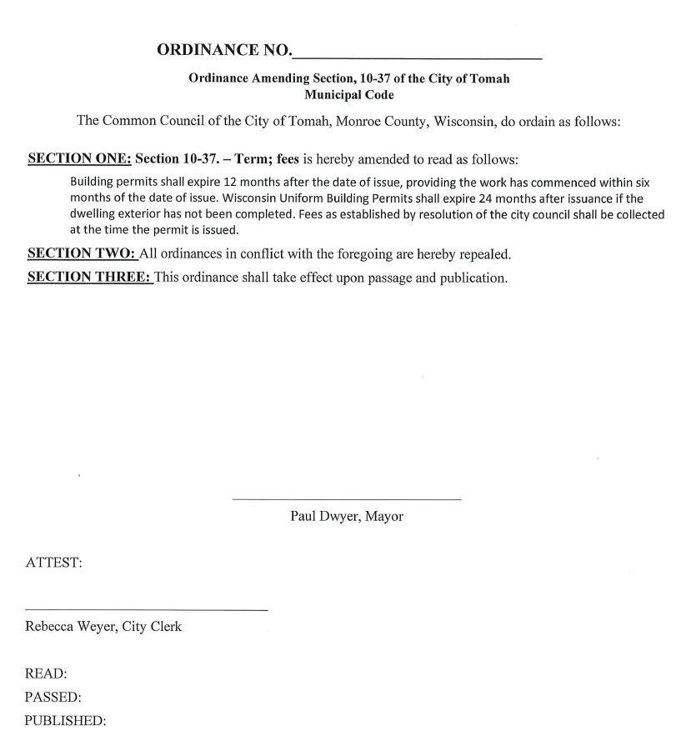

Amendment of Ordinance Section 52-34(a)(3) First Reading, Second Reading, Adoption
Motion by Peterson, second by , to waived by Zabinski, e first verbatim reading of the ordinance amending Section 52-34(a)(3). Motion carried.

Motion by Peterson, second by Zabinski, to waive the second verbatim reading of the ordinance amending Section 52-34(a)(3). Motion carried.

Motion by Peterson, second by Zabinski, to adopt the ordinance amending Section 52-34(a)(3). Motion carried.
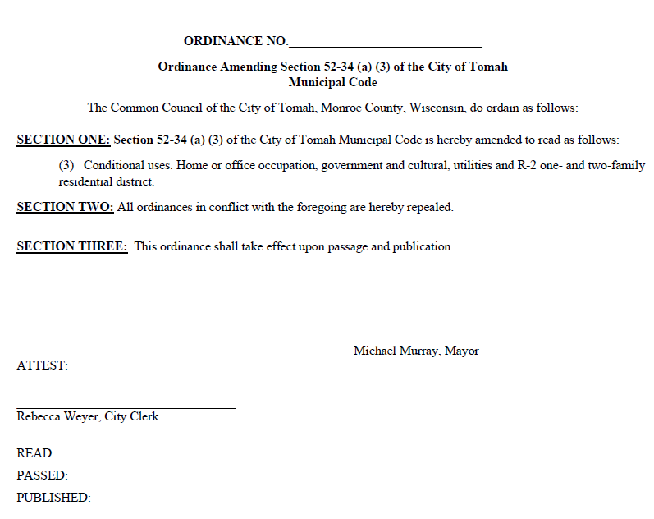
Approval of Amendment of Chapter 5 City of Tomah Personnel Manual
Motion by Zabinski, second by Glynn, to approve the amendments to Chapter 5 City of Tomah Personnel Manual as submitted. Motion carried.

Approval of sale of equipment to the Village of Warrens
Motion by Yarrington, second by Zabinski, to approve the sale of the old city recycling truck to the Village of Warrens. Motion carried.

Resolution Authorizing Payment of Monthly Bills
Motion by Zabinski, second by Glynn, to approve the resolution authorizing the payment of monthly bills in the amount of $2,744,527.79. Motion carried.

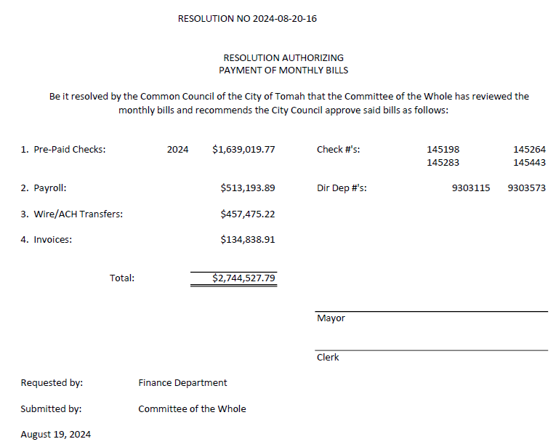

July 31, 2024 Cash and Investments Report
Motion by Zabinski, second by Peterson, to approve the July 31, 2024 Cash and Investments Report. Motion carried.

Ordinance Creating Section 2-559 through 2-563 of the Municipal Code of the City of Tomah for Creation of an Ordinance Committee
Motion by Peterson, second by Zabinski, to waive the first verbatim reading of the ordinance creating Section 2-559 through 2-563 of the Municipal Code of the City of Tomah for Creation of an Ordinance Committee. Motion carried.

Motion by Peterson, second by Zabinski to have the City attorney revise the ordinance so that it states the committee is as needed and to have the mayor choose the members at the next meeting. Motion carried.

Appointment of Laura Holloway to fulfill the remaining term of Garret Nelson ending in April, 2027
Motion by Peterson, second by Zabinski, to approve the appointment of Laura Holloway to the Chamber/CVB to fulfill the remaining term of Garrett Nelson ending in April, 2027. Motion carried.

ADJOURN
Motion by Peterson, second by Zabinski, to adjourn the meeting. Motion carried. The meeting was adjourned at 8:59 p.m.

________________________________
Paul Dwyer, Mayor

________________________________
Rebecca Weyer, City Clerk

