Minutes FOR Common Council September 17, 2024

Call to Order, Pledge of Allegiance, Roll Call
Mayor Paul Dwyer called the meeting to order at 6:30 p.m. After the Pledge of Allegiance, roll call was taken. Present: Paul Dwyer, Travis Scholze, Richard Yarrington, Shawn Zabinski, John Glynn, Nicole Hart, Patrick Devine, Nellie Pater, and Dean Peterson. Absent: none. Also present: Kirk Arity, Becki Weyer, Molly Powell, Tim Adler, Irma Keller, Tina Thompson, and Pam Buchda. The meeting was recorded by Hagen Sports network and was available via zoom. All motions are unanimously approved unless otherwise notated.

ANYONE DESIRING TO APPEAR TO COUNCIL
No one desired to appear to Council.

Mayor
The mayor did not give a report.

Senior Executive Team Monthly Report
SET provided a monthly written report. Kirk Arity answered questions from the Council.

Public Safety August Monthly Report
Fire: Adler covered details of the recent fire. There was a total loss of the mobile home and detached garage, along with damage to the neighboring house. Fire inspectors are out working on the second round of inspections in the city. Alder will be giving a presentation at the Firefighter’s Association on his experience with downtown fires, which are unfortunately common in other municipalities.
Ambulance: Call volume continues to rise every month. On August 29th they had the TAAS annual meeting discussing the per capita rate. The per capita rate will stay at $20.00 from 2024 to 2025. The ambulance remount will be completed soon.

Library
There were 1999 eBook and 5020 physical checkouts during the month of August. Keller provided an update on the new books at the library. She gave a recap of the recent and upcoming activities and events. There has been a delay in the completion of the library stairs. Those looking for additional information can visit the library’s website at tomahpubliclibrary.org.

Chamber and CVB
There is good engagement with the social media efforts. They are planning the area guide. They are expecting an increase in tourism during Cranfest. The leadership program has started.

September 2024 Senior & Disabled Services Department monthly report
Buchda provided a monthly written report and gave a summary to the Council. November 8th is the last day to sign up for a booth for the upcoming craft fair. The annual Halloween party is coming up on October 31st. Buchda is looking for volunteers. Trick or treat hours are 4pm-7pm on Halloween night.

CONSENT AGENDA:
Motion by Zabinski, second by Yarrington, to approve the following consent agenda:

A. Approval of Minutes from August 20, 2024
B. Special Event Outdoor Cabaret License for the Greater Tomah Area Chamber of Commerce for the 800 and 900 blocks of Superior Avenue for six “Downtown Thursday Nights” concert events in July and August of 2025.
C. Special Beer and Wine License Application by the Tomah Lions Club for Downtown Thursday Nights in July and August of 2025.
D. Special Beer Permit Application by Tomah Firefighters Association for Hunters Night Out on November 2, 2024.
E. August 31, 2024 Cash and Investments Schedule

Motion carried.

Resolution Authorizing Payment of Monthly Bills
Motion by Scholze, second by Zabinski, to approve the resolution authorizing payment of monthly bills in the amount of $2,826,141.52. Motion carried.
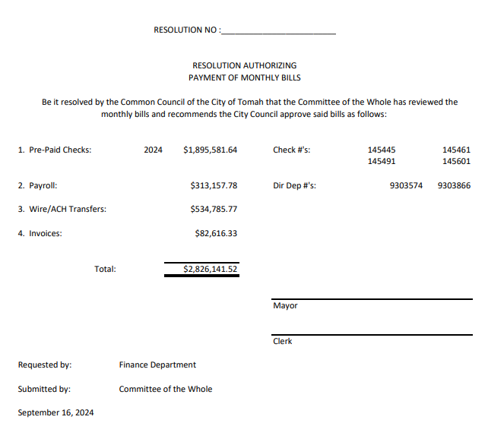

Ordinance to Create Ordinance Committee (First Reading, Second Reading, Adoption)
Motion by Scholze, second by Yarrington, to waive the first verbatim reading of the ordinance to create an ordinance committee. Motion carried.
Motion by Zabinski, second by Pater, to waive the second verbatim reading of the ordinance to create and ordinance committee. Motion carried.
Motion by Zabinski, second by Glynn, to adopt the ordinance to create the ordinance committee. Motion carried.
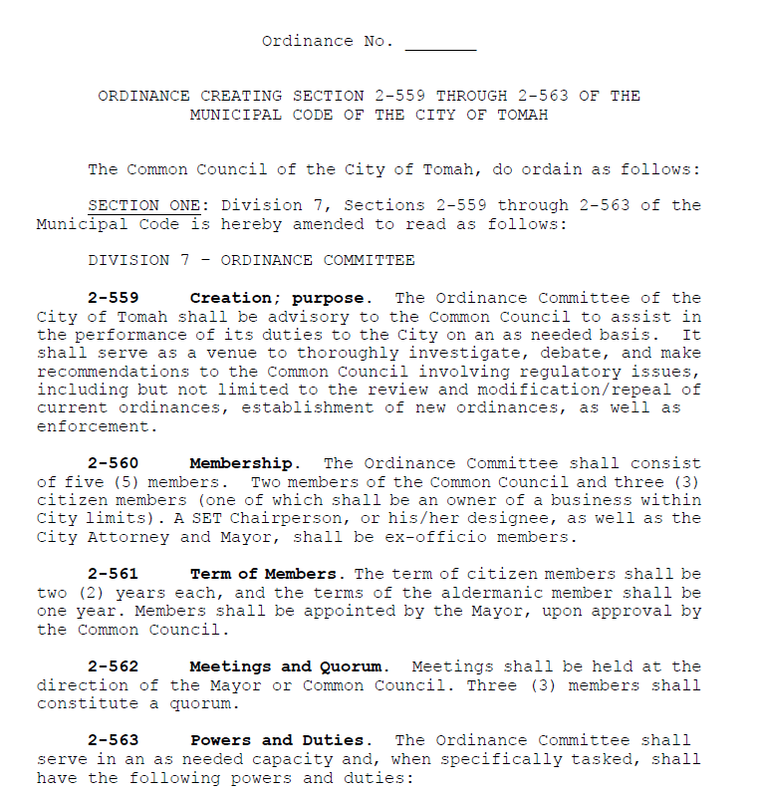
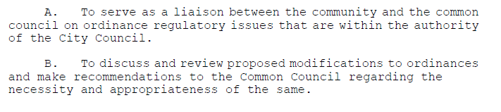
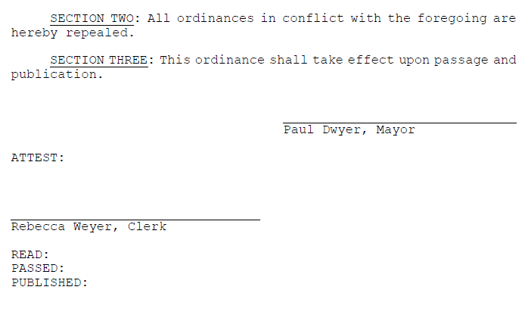
Tomah K9 Unit Officer Vehicle Policy Change approval
Motion by Glynn, second by Scholze, to change the limit to the K9 officer vehicle policy to 50 miles from 15 miles. Motion carried.

K9 Training – Canada
Motion by Yarrington, second by Glynn, to approve the K9 officer training in Canada in early 2025. Motion carried.

Ordinance Re-Zoning Property Parcel #286-02651-5301
Motion by Zabinski, second by Glynn, to waive the first verbatim reading of the ordinance Re-Zoning Property Parcel #286-02651-5301. Motion carried.
Motion by Zabinski, second by Glynn, to waive the second verbatim reading of the ordinance Re-Zoning Property Parcel #286-02651-5301. Motion carried.
Motion by Zabinski, second by Pater, to adopt the ordinance rezoning property parcel #286-025651-5301. Motion carried.
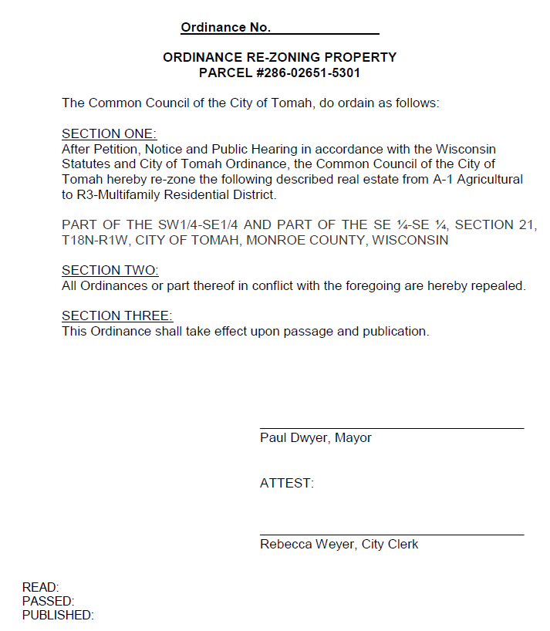

Appointment of Dean Peterson, Nellie Pater, Shawn Zabinski, Paul Dwyer, Chris Popp, Molly Powell, and Penny Precour to the Ad Hoc Committee to research a City Administrator
Motion by Pater, second by Zabinski, to approve the mayor’s appointment of Dean Peterson, Nellie Pater, Shawn Zabinski, Chris Popp, and Penny Precour to the ad hoc committee to research a City Administrator and to appoint Molly Powell and Paul Dwyer as ex-officio. Motion carried.

Appointment of James Stroh II, Mike Webber, Helene Stein, John Glynn, Patrick Devine, Paul Dwyer, and Penny Precour to the Ordinance Committee
Motion by Pater, second by Zabinski, to approve the mayor’s appointment of James Stroh, Mike Webber, Helene Stein, John Glynn, Patrick Devine, Paul Dwyer, and Penny Precour to the Ordinance Committee. Motion carried. The SET Chairperson, Mayor, and City Attorney will be ex-officio. Motion carried.

Approval of Disallowance of Claim
Motion by Peterson, second by Pater, to approve the disallowance of the claim against the City of Tomah by Madison Schams. Motion carried.

Approval of Election Results August 12, 2024
Motion by Yarrington, second by Zabinski, to approve the election results for the August 12, 2024 election as presented. Motion carried.

Adjourn to closed session pursuant to Wis Stat. § 19.85(1)(c) Considering employment, promotion, compensation, or performance evaluation data of any public employee over which the governmental body has jurisdiction or exercises responsibility
Motion by Zabinski, second by Yarrington, to adjourn to closed session for the agenda item stated above. The meeting adjourned at 7:06. p.m.

The meeting resumed from closed session at 7:29 p.m.

Action on Closed session (if Necessary)
Motion by Peterson, second by Yarrington to authorize the clerk to recruit for the open City Treasurer position and to hire a temporary professional service for 10-15 hours per week in the interim, and to authorize payment to Molly Powell to work on an hourly basis as needed during the transition period. Motion carried.

ADJOURN
Motion by Peterson, second by Pater, to adjourn. The meeting was adjourned at 7:33 p.m.

__________________________
Mayor Paul Dwyer

_____________________________
Rebecca Weyer, City Clerk

