**Minutes** **Council AND Annual Budget Hearing November 19, 2024**

**Call to Order, Pledge of Allegiance, Roll Call**

The meeting was called to order by Mayor Paul Dwyer at 6:31 p.m. After the Pledge of Allegiance, roll call was taken. Present: Paul Dwyer, Travis Scholze, Richard Yarrington, Shawn Zabinski (remote), John Glynn, Patrick Devine, Nellie Pater, and Dean Peterson. Absent: District 5 vacancy. Also present: Kirk Arity, Becki Weyer, Tim Adler, Joe Protz, and Pam Buchda. The meeting was recorded by Hagen Sports Network and was available via Zoom. All motions are unanimously approved unless otherwise indicated.

**ANYONE DESIRING TO APPEAR TO COUNCIL**

No one desired to appear before the Council.

**Candidate Submissions for District 5 Alderperson**

Mitch Koel and Eric Prise presented written submissions to the District 5 Alderperson vacancy.

**Candidates Present for District 5 Alderperson Vacancy**

Koel and Prise were each given time to speak to the Council about why they believe they are the best candidate to fill the vacancy. Koel spoke first and reiterated that he has already served on the Council and would like to again take the opportunity to serve. Prise stated he was a former Alderperson as District 5 and currently serves on the Long-Range Planning Committee and the Planning Commission. He intends to seek the District 5 seat in the upcoming April Election.

**Council Decision on Appointment of District 5 Alderperson to fulfill the remaining term of Nicole Hart ending in April 2025**

The Council opted to use a secret ballot format to select his/her choice for the District 5 vacancy. Mitchell received four votes and Prise received three votes. Mitchell Koel was appointed to the remaining term of District 5 Alderperson ending in April, 2025.

**Swearing in of District 5 Alderperson**

The City Clerk swore in Mitch Koel to the District 5 Alderperson seat. Koel took his place at the Council.

**2025 BUDGET PUBLIC HEARING:**

**Open the Public Hearing**

Mayor Dwyer opened the public hearing at 6:40 p.m.

**2025 Budget Hearing Summary**

Weyer provided a summary of the October budget workshop budget summary:

Tax levied dollars account for 42% of the total budget revenue, followed by intergovernmental revenues, such as payments from the state of Wisconsin. The city is limited to budget increases from the previous year based on the net new construction percentages reported by the state. From 2024 to 2025, the net new construction was .47% which is only a total of $34,207 increase in the levy. Last year, the budget was balanced with the help of increased state shared revenue, but in 2025, there was a $196,000 shortfall which will be balanced with the remainder of ARPA funds. State shared revenue only increased 2.0% from 2024 to 2025, which is not enough to balance against the rising costs of goods and services. At the October meeting, Powell urged the Council to think ahead on how to maintain operational costs in the future. One solution would be to close one or more TIDs. It is a process that will take several years to complete but will have a significant impact on the tax dollars that can be used for the General Fund vs. going back into a TID. Powell suggested that the $84,000 in ARPA funds be used in 2026, along with closure of TID 11, which will return about $90,000 in tax revenue to the city. Beyond 2026, she suggested staff look at closure of TID 8 after debts are paid. The Economic Development director should assist in promoting more net new construction. In addition, she suggested that staff evaluate its service contracts, particularly IT services, as they are a large expense.

**Request for Public Comment**

No one desired to give a public comment.

**Close the Public Hearing**

Mayor Dwyer closed the public hearing at 6:47 p.m.

**Resolution Adopting the 2025 Budget**

Motion by Scholze, second by Pater, to approve the Resolution adopting the 2025 Budget and establishing the tax rate. The final budget includes a levy of $6,145,318 and the tax rate to be established at $6.31 per $1,000 of assessed property value. Motion carried with no negative vote.

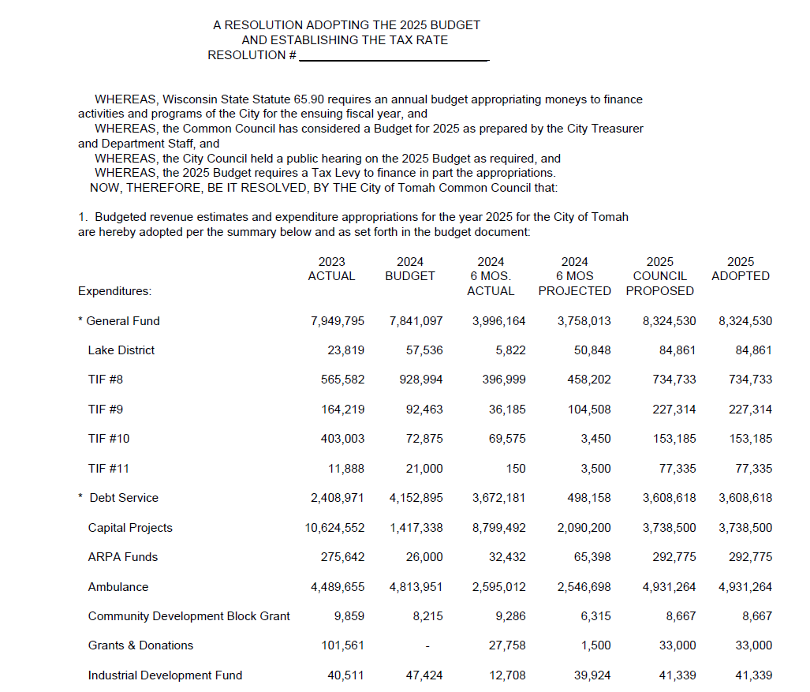

**Mayor**

The Mayor gave a report that the buildings downtown and house affected by the fire have been torn down and look better. He stated he is proud of how things in the city are going.

**SET Report November Meeting**

Arity and Weyer presented a monthly SET written report to the Council. The focus has been recruiting the Treasurer and Economic Development Director positions. There are some smaller properties that have been listed that are available for potential economic development. They are in the process of reaffirming their registration for Sam.gov. Powell is still working on the renewal but there have been some hurdles. The Cybersecurity grant has been signed. SET met with Horizon Development to go over several properties in the city that could be good for their projects. There is an upcoming meeting with Forward Tomah that is focused on additional housing in the city. Arity asked the Council and constituents to provide additional details and information when lodging a complaint in areas of the city.

**Public Safety October Monthly Report**

Adler provided a monthly written report.

Fire: They continue to be busy and are advertising for an eligibility list. They are reviewing job descriptions to be brought back to the Council over the next couple of months.

EMS: Continue to run record amounts. There were two dead deer on the interstate that were hit by ambulances. One caused substantial damage and had to be turned into the insurance agency.

**Tomah Parks and Recreation Program Report**

Protz provided a monthly written report and gave the Council a summary of the upcoming events at Recreation Park. There has been some vandalism in the Comfort Station bathrooms.

**Library**

Keller was not in attendance. The annual library fundraiser will be on Tuesday, December 5 hosted by Friends of the Library.

**Senior & Disabled Services Department Monthly Report**

Buchda provided a monthly written report and provided the Council with an update of upcoming events and fundraisers at the Senior Center. The annual craft fair will be on November 23 from 9am to 3:30 pm at Recreation Park.

**Request to transfer $2,500 from a revenue account to an expense account**

Motion by Glynn, second by Pater, to approve the budget amendment to deposit a $2500 refund check to revenue account 01-48420 and transfer to expense account 01-52100-3400. Motion carried.

**Resolution for the Payment of Monthly Bills**

Motion by Scholze, second by Pater, to approve the resolution authorizing payment of monthly bills in the amount of $1,767,912.70. Motion carried.

**Secondhand Article Dealer Application for ecoATM, LLC**

Motion by Yarrington, second by Glynn, to approve the secondhand article dealer license application for ecoATM, LLC for the period of 01/01/2025 – 12/31/2025. Motion carried.

**Approval of Minutes from October 05, 2024**

Motion by Scholze, second by Peterson, to approve the minutes from October 5, 2024. Motion carried.

**Approval of Minutes from October 15, 2024**

Motion by Glynn, second by Scholze, to approve the minutes from October 15, 2024. Motion carried.

**Final Approval of Downtown Facade Improvement Program and amendment to TIF Development Incentives Program Policy Manual**

Motion by Scholze, second by Glynn, to approve the Downtown Façade Improvement Program and amendment to the TIF development Incentives Policy Manual as presented. Motion carried with one negative vote (Yarrington).

**Adjourn to Closed Session Pursuant to Wis Stat § 19.85(1)(c) Considering employment, promotion, compensation, or performance evaluation data of any public employee over which the governmental body has jurisdiction or exercises responsibility in order to discuss candidates for the City Treasurer Position**

Motion by Glynn, second by Peterson, to adjourn the meeting to closed session pursuant to Wis Stat § 19.85(1)(c). Motion carried. The meeting adjourned to closed session at 7:15p.m.

_____________________________

Mayor Paul Dwyer

______________________________

Attest: Rebecca Weyer, City Clerk