😊
 |  | KUPPER-RATSCH SENIOR CENTER A Community Gathering Place |  |  | SENIOR & DISABLED SERVICES DEPARTMENT
Phone: 608-374-7476 Fax: 608-374-7462 |  | 1002 Superior Ave. Tomah, WI. 54660 Facebook: Tomah Senior Center |  |  | E-mail: pbuchda@tomahwi.gov
SEPTEMBER 2024 |  | ACTIVITY/EVENT CALENDAR |  |  | Subject to change
Page 22 | COFFEE & VISITING:  9:00am Monday through Friday | SENIOR CENTER HOURS: Monday through Friday (except holidays) from 8:30am to 4:30pm (& other times & days as booked)  LUNCH: (ADRC of Monroe County Meal Site in Tomah) is Monday through Friday at 11:30am, except Holidays |  | Page 23

Sunday | Monday  6:00 Euchre at American Legion | Tuesday All day Free Pool at Break Room 6:30 Trivia Night at Taphouse Twenty | Wednesday  9:00pm Karaoke at Break Room | Thursday 12-3 1st Th Bingo at Elbow room 7:00pm DJ Trivia at Break Room | Friday  7-10pm Live Music at Brick Sip Haus 9:00pm Music at Break Room | Saturday
01 World Letter Writing Day American Chess Day Cherry Popover Day Ginger Cat Appreciation Day  Aug31 – Sept 2: 43rd Millston MDA  Labor Day Weekend Softball  Tournament & Celebration | 02 LABOR DAY Holiday 1945: WWII-Japan Formal Surrender  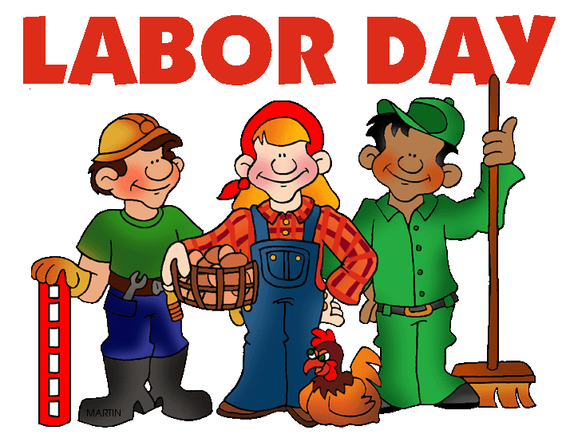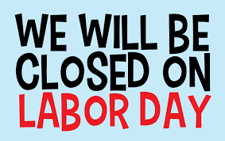 | 03 MOON–New //1st Day of School US Bowling League Day  8:30 Hospice Community Advisory Board  9:00 LINE DANCING  12:00 Rotary Meeting  12-12:50 PFEIFFER  12:30 GAMES OF CHOICE  1:00 EUCHRE ($2;10cent bump)  1:00 Parkinson Support Grp at Hosp  3-4:30 2nd Harvest Food at Rec.Park  5:30 Special Needs Committee  6:30 Senior &Disabled Service Brd | 04 Nat’l Wildlife Day Newspaper Carrier Day  9:00 WELLNESS EXERCISE  10:30-3:30 QUILTING GROUP  11am-6pm Farmers Market-Gillett Park  12:30 PINOCHLE  1:00 CANASTA  1:00 HAND & FOOT  1:00 WRAP Conference Meeting  6:00 Rotary Rally Planning Meeting | 05 World Coconut Day Int’l Day of Charity Nat’l Cheese Pizza Day Be Late For Something Day  9:00 LINE DANCING  9:00 CONDITIONING WITH CHAD  10:15 ASL STUDY GROUP  1:00 BINGO (50 cents card)  3:00 Healthy Brain Coalition of MC Meeting  6:00 Noah Ark Preschool Leadership Meeting | 06 Nat’l Read A Book Day Elvis Explosion-Lax Center Tomah’s Garage Sale Weekend Deadline Chamber Golf Outing  9:00 WELLNESS EXERCISE  10:15 Singin n Swingin Band  Sponsor: Marian Beebe  12:00 Adaptive FITNESS 4 ALL  1:00 BINGO (50 cents/card)  5-gone Fish Fry at American Legion $15  7:15 PACKERS at Philadelphia Eagles  (TV-Peacock) | 07 World Beard Day Nat’l Hummingbird Day Tomah’s Garage Sale Weekend Hindu: Ganesh Chaturthi (10day)  6am-1pm Farmer’s Market-Gillett Park
08 1966 Star Trek Day World Physical Therapy Day Int’l Literacy Day Nat’l Grandparents Day Pardon Day Christian: Nativity of Mary  2:00- 4:00 SUNDAY FUNDAY At Senior Center For special needs persons & their parents/caregivers | 09 1859: California Admission Nat’l Teddy Bear Day  9:00 WELLNESS EXERCISE  9:00 BEGINNER LINE DANCE  1:00 BINGO BASH (free-play 1)  1:00 VA Caregiver Support Group  1:30-3:30 AAUW 2025 Conference Planning  4:30-5:30 Free Community Meal at  Masonic Lodge | 10 1662: Naval Sea Cadet Corp World Suicide Prevention Day Nat’l Swap Ideas Day  8:30 City Dept. Head mtg.at City Hall  9:00 LINE DANCING  12-1 Greif Support Grp – ADRC Sparta  12:30 Visiting with Officer Audra Gomez  12-12:50 PFEIFFER  12:30 GAMES OF CHOICE  1:00 EUCHRE & 1:00 BRIDGE  2:00 WI. Coalition for Social Connection  4:30 TGHSH Meeting  ____ Presidential Debate (TV-ABC) | 11 MOON- First Quarter PATRIOT Remembrance DAY  9:00 WELLNESS EXERCISE  10:00 Cancer Survivorship Grp at Hosp  10:30-2:00 CREATIVE CORNER  11am-6pm Farmers Market-Gillett Park  11-1 Coffee Time &/or Memory Screening  with Emily Reitz, Dementia Care Specialist  12:30 PINOCHLE & 1:00 CANASTA  1:00 HAND & FOOT  4:15 Housing Mtg.  5:30 Read Between the Lines Book Club | 12 Nat’l Day of Encouragement Nat’l Chocolate Milkshake Day  9:00 LINE DANCING  9:00 CONDITIONING WITH CHAD  9-11 ENERGY ASSISTANCE  Flocks Guardians - Deanna  10-12 State Aging Advisory Council Meeting  10:15 ASL STUDY GROUP  1:00 BINGO (50 cents card)  4:00 Tomah Concert Association Board Mtg. | 13 1813: Uncle Sam Day Chambers Annual Golf Outing Neighborhood Block Party Nat’l Cinema Day  9:00 WELLNESS EXERCISE  10:00 Public Budget Mtg Human Service  10:15 MUSIC by Michael Slater  Sponsor: Volunteers his time & talents  12:00 Adaptive FITNESS 4 ALL  1:00 BINGO (50 cents/card)  5-9:30 Tomah’s Neighborhood Block  Party at Recreation Park-see page 31 | 14 1814: Star-Spangled Banner 1914: VFW Ladies Auxiliary Nat’l Cream Filled Donut Day Neighborhood Block Party by Rotary Club of Tomah World Hindu Day/Hindu Diwas  6am-1pm Farmer’s Market-Gillett Park  7am-10pm Tomah’s Neighborhood Block Party at Recreation Park –  see page 31 for more info.
15 Int’l Day of Democracy Nat’l Women’s Friendship Day Wife Appreciation Day Family Promise Week begins Christian: Feast of Holy Cross  12:00 PACKERS vs Indianapolis Colts  (TV-FOX) | 16 MOON–Full/ Nat’l Step-Family D 1620: Mayflower Day 1919: American Legion day Nat’l Tradesmen Day Feast of Our Lady of Sorrows  9:00 WELLNESS EXERCISE  9:00 BEGINNER LINE DANCE  10:30 BASKET WEAVING $20  1:00 BINGO (50 cents/card)  4:30-5:30 Free Community Meal  6:30 City Committee of the Whole  7:00 School Board Meeting at RKLC | 17 1787:Constitution & Citizenship Day // Nat’l IT Professional’s Day Chinese Moon Festival Feast of St.Francis of Assisi  9:00 LINE DANCING  12:00 Rotary Meeting  12-12:50 PFEIFFER  12:30 GAMES OF CHOICE  1:00 EUCHRE ($2;10cent bump)  5:30-6:30AAUW Branch Presidents Mtg.  6:30 City Council Meeting-City Hall | 18 1947: US Air Force Int’l Equal Pay Day Nat’l HIV/AIDS & AGING Awareness Day  9:00 WELLNESS EXERCISE  11-1 Coffee Time-Janessa Peterson  St. Croix Hospice Care Transition  10:30-3:30 QUILTING GROUP  12:30 PINOCHLE & 1:00 CANASTA  1:00 HAND & FOOT  6:00 Montessori Governance Brd | 19 La Crescent Apple Fest begins ADRC Vintage Vagabond Trip  9:00 LINE DANCING  9:00 CONDITIONING WITH CHAD  9-11 BETTER HEARING -Tom Vierling  10:15 ASL STUDY GROUP  1:00 BINGO (50 cents card)  6:30 Neighbor For Neighbor Board meeting  7:30 Light Up La Crescent Parade | 20 Nat’l POW/MIA Recognition Day La Crescent Apple Fest  9:00 WELLNESS EXERCISE  10:15 MUSIC by Blaine Meyer  Sponsors: Volunteers his time & talents  11:00 Lunch Memory Café - Barney Ctr  12:00 Adaptive FITNESS 4 ALL  1:00 BINGO (50 cents/card)  1-2 Caregiver Support Grp-ADRC Sparta  5-gone Fish Fry at American Legion $15 | 21 Int’l Day of Peace Nat’l Dance Day /// Batman Day Oktoberfest in Germany La Crescent Apple Fest  6am-1pm Farmer’s Market-Gillett Park  9-12 Free E-Waste Recycling at parking  lot of Aquatic Center  2:00 Tomah Concert Association at THS  is ‘Street Corner Symphony’  4:30 AM VETS meeting
22 AUTUMN EQUINOX Int’l Daughters Day // World Rivers Day // Nat’l Girls Night Hobbit Day -BD Frodo & Bilbo Nat’l Elephant Appreciation Day La Crescent Apple Fest ends Family Promise Week ends  12:00 PACKERS at Tennessee Titans  (TV-FOX)  1:00 King Apple La Crescent Parade | 23 Int’l Day of Sign Language Nat’l Family Day Falls Prevention Awareness Wk  9:00 WELLNESS EXERCISE  9:00 BEGINNER LINE DANCE  1:00 BINGO (50 cents/card)  4:30-5:30 Free Community Meal at  Masonic Lodge | 24 MOON-Last Quarter World Gorilla Day Nat’l Voter Registration Day  8:30 City Dept. Head mtg.  9:00 LINE DANCING  12-12:50 PFEIFFER  12:30 GAMES OF CHOICE  1:00 EUCHRE ($2;10cent bump)  2-3 Men’s Club Committee at ADRC  5:30 AAUW meeting | 25 Nat’l Comic Book Day Nat’l Daughters Day WASC Conference Begins in EC  9:00 WELLNESS EXERCISE  10:30-2:00 CREATIVE CORNER  9-11 Coffee Time w/Stephanie Haas,ADRC  11am-6pm Farmers Market-Gillett Park  12:30 PINOCHLE & 1:00 CANASTA  1:00 HAND & FOOT  6/7: Lion’s Membership Meeting  6-9 Open Mic at Brick Sip Haus | 26 La Crosse OctoberFest begins Johnny Appleseed Day TASD Early Dismissal- Cranfest  9:00 LINE DANCING  9:00 CONDITIONING WITH CHAD  10:15 ASL STUDY GROUP  11-1 Coffee Time w/staff from Tomah  Health Hospice & Palliative Care  1:00 BINGO (50 cents card)  6:00 Take Mystery Out Medicare-Sparta  7:00 Torchlight Parade in La Crosse | 27 Nat’l Day of Forgiveness TASD No school- CRANFEST Cranberry Festival in Warrens Octoberfest in La Crosse WASC Conference ends  9:00 WELLNESS EXERCISE  10:15 MUSIC by Michael Slater  Sponsor: Volunteers his time & talents  12:00 Adaptive FITNESS 4 ALL  1:00 BINGO (50 cents/card) | 28 World Rabies Day/Int’l Rabbit Day Nat’l Good Neighbor Day Nat’l Public Lands Day Nat’l Hunting & Fishing Day Cranberry Festival in Warrens Octoberfest in La Crosse  6am-1pm Farmer’s Market-Gillett Park  10:00 Maple Leaf Parade in La Crosse 
29 1899: VFW Day // Gold Star Mother’s Day // Confucius Day Urban Wildlife Refuge Day Cranberry Festival ends Octoberfest in La Crosse ends  12:00 PACKERS vs Minnesota Vikings  (TV-CBS)   1:00 CranFest PARADE in Warrens | 30 World Maritime Day Nat’l Love People Day Nat’l Hot Mulled Cider Day  9:00 WELLNESS EXERCISE  9:00 BEGINNER LINE DANCE  1:00 BINGO (50 cents/card)  4:30-5:30 Free Community Meal at  Masonic Lodge | Back To School Month  Happy Cat Month  Healthy Aging Month  Hispanic Heritage Month  Nat’l Senior Center Month  Nat’l Sewing Month  Self-Improvement Month   | 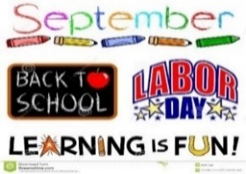 | BIRTHDAYS  04: Ruth Beckler & Colleen Carl  04: Blaine Schroeder  06: Marvin Parker & Cathy Neumann  07: Marilyn Kortbein & Bennett Sprotle  08: Ruby Weeks-Fortney  11: Jaelyn Reeher & 12: Pat Johnson  14: Gloria Butts & Lauri Shumway  15: Becky Fitzpatrick & Lily Reeher | BIRTHDAYS  16: Pat Block &Adam ‘Dan’ Danielewitz  18: Lina Lewis  22: Terri Rice  24: Barb Akers & 25: Mario Ramirez  29: Marilyn Randolph  30: Lloyd Sutherland  NOTE: If I have missed anyone’s birthday, please let me know. | BIRTHSTONE: Sapphire;Peridot;Agate;  FLOWERS: ASTER; Morning Glory;  COLORS: Brown  MEANING: Love; Wisdom; Calmness; Affection;; Daintiness; Clear Thinking; Loyalty; Faithfulness; Trust; Purity;  ZODIAC: Virgo 8/23-9/22  Bear (Native American))  Libra 9/23-10/22  Raven (Native American)
😊 NOTE(S): Sept 26-Oct 06: 6:00 Free Manhattan Short Film Fest at Library (You be the Judge-vote for films). WASC Conf 25-27-Pam.

