MISSION STATEMENT The City of Tomah’s Senior & Disabled Services Department’s mission is to offer ongoing programs and services (in the areas of recreation & leisure activities, and in educational & health programs) and senior meals on a regular basis in a safe place for Tomah’s citizens (especially our senior and disabled people). Tomah Timberwolves  Credo by Del Goetz Respect the elders. Teach the young. Cooperate with the pack. Play when you can. Hunt when you must. Rest in between. Share your affections. Voice your feelings. Leave your mark.  PHOTO ALBUM…Making Memories  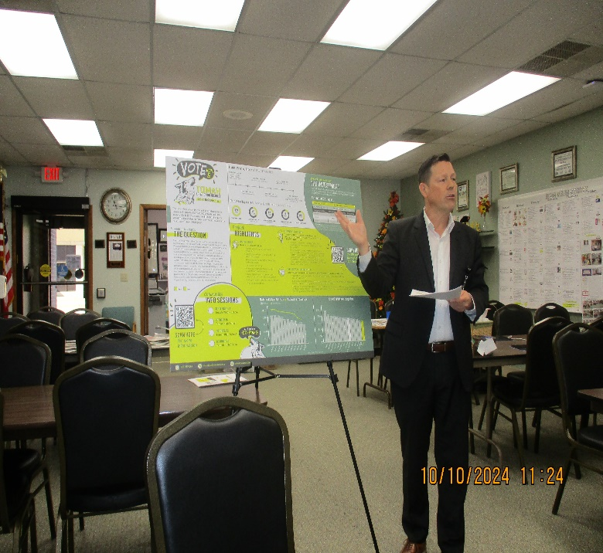 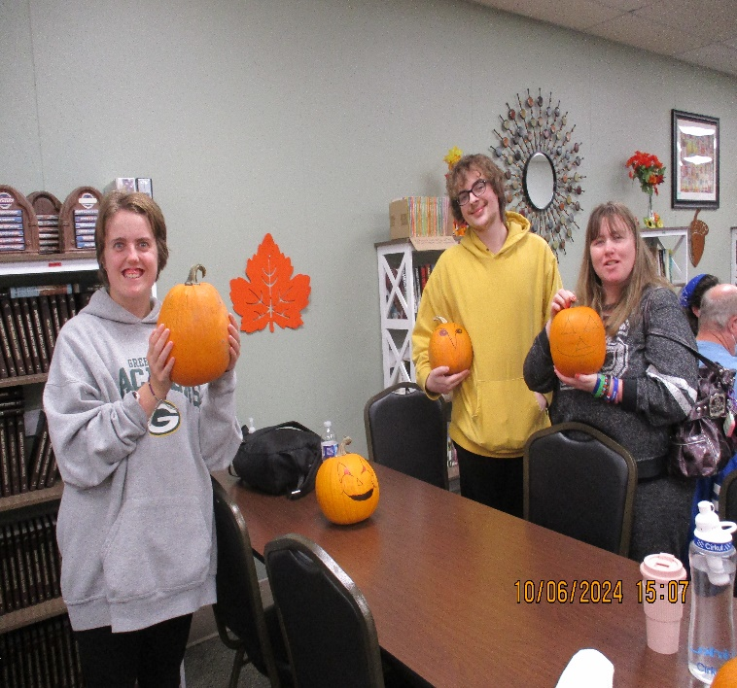  TASD CAPITAL REFERENDUM PRESENTATION by Dr. Mike Hanson Good Presentation & Question/Answer Session. Thursday, October 10, 2024 SUNDAY-FUNDAY EVENT Creating faces on pumpkins. Thanks to Sarah Moseley for donating pumpkins. Sunday, October 06, 2024  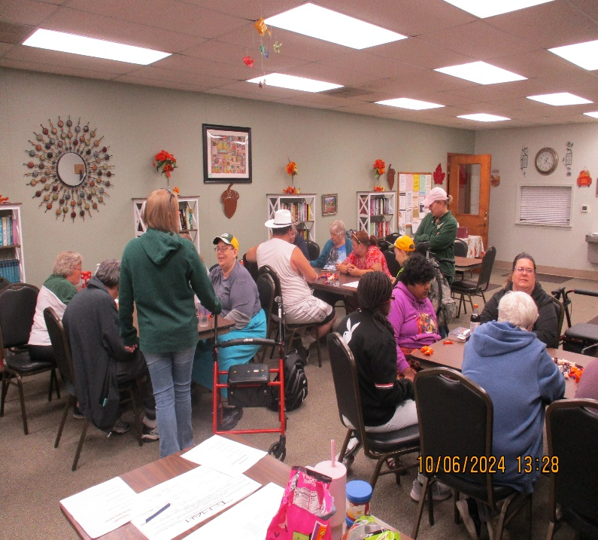 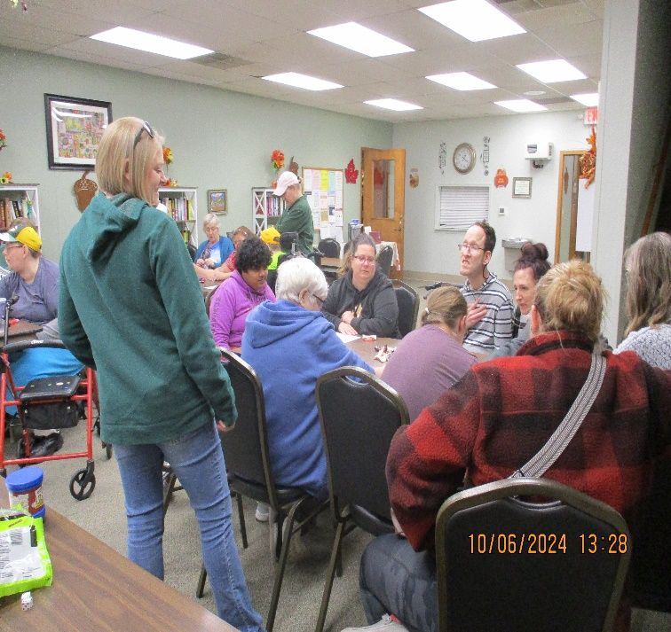  SUNDAY-FUNDAY EVENT Fellowship, Fun & Table Games of Choice. We really enjoy spending time with each other. Sunday, October 06, 2024 SUNDAY-FUNDAY EVENT Fellowship, Fun & Table Games of Choice. Come and join us next month for bowling. Sunday, October 06, 2024  Page 04 |  | City of Tomah’s Dept. of SENIOR & DISABLED SERVICES 608-374-7476 Fax: 608-374-7462 pbuchda@tomahwi.gov Kupper-Ratsch Senior Center A Community Gathering Place 1002 Superior Ave. Tomah, WI. 54660 Facebook page – Tomah Senior Center  NOVEMBER 2024 NEWSLETTER INSERT  PHOTO ALBUM…Making Music Memories  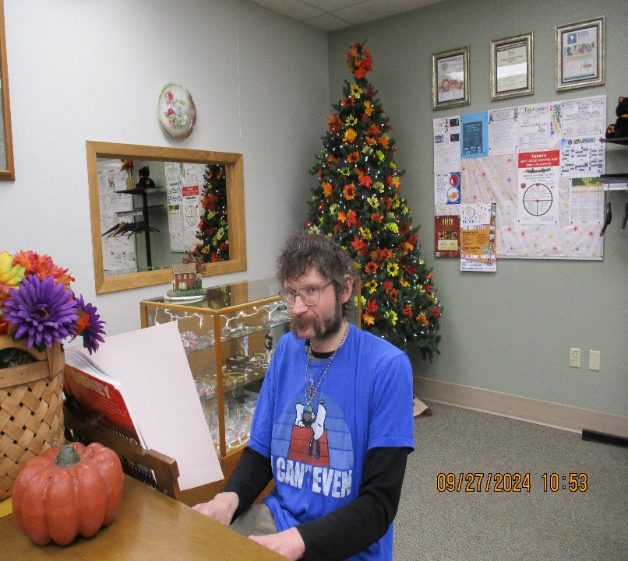 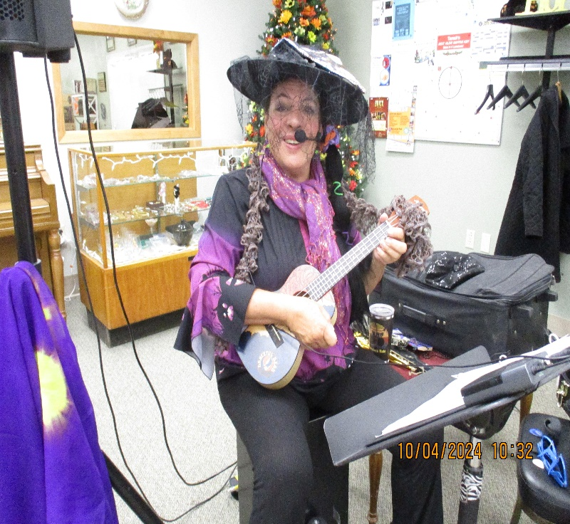  MICHAEL SLATER “Could listen to his music all day.” SPONSOR: Volunteers his time & talents Friday, September 27, 2024 KATE ROBERTS McCLAIN What an entertainer! SPONSOR: Marian Beebe Friday, October 04, 2024  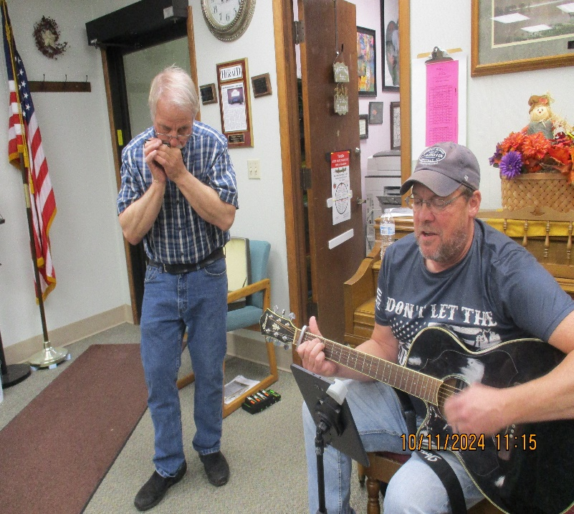 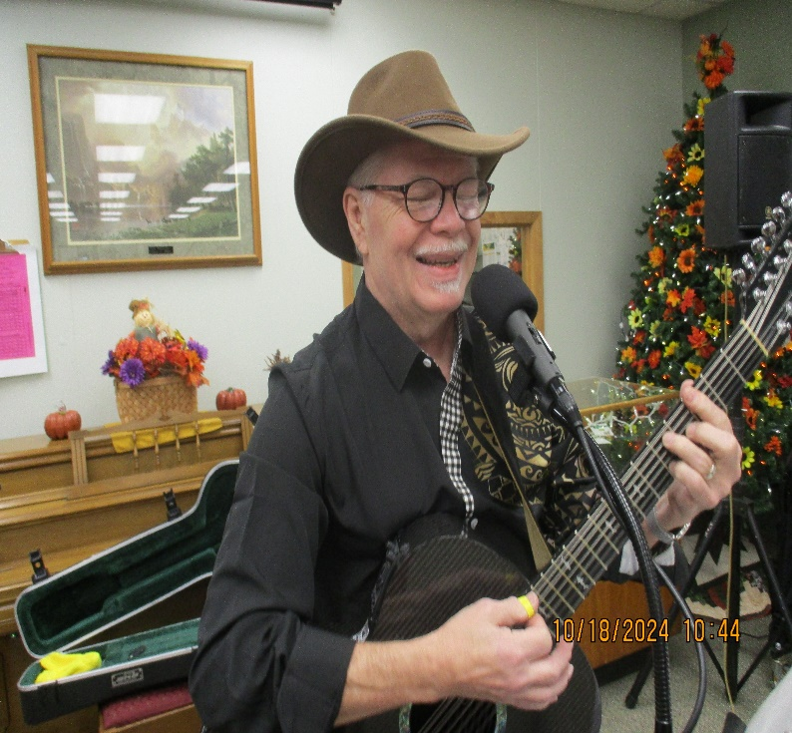  BLAINE MEYER, guitar & singing & GARY FELBER, harmonicas SPONSOR: Volunteers their time & talents Friday, October 11, 2024 KEVIN MATTSON Always enjoy Kevin’s music and humor. SPONSOR: Marian Beebe Friday, October 18, 2024  Page 01

City of Tomah’s Dept. of SENIOR & DISABLED SERVICES 608-374-7476 Fax: 608-374-7462 pbuchda@tomahwi.gov Kupper-Ratsch Senior Center A Community Gathering Place 1002 Superior Ave. Tomah, WI. 54660 Facebook page – Tomah Senior Center  PHOTO ALBUM…Making Memories  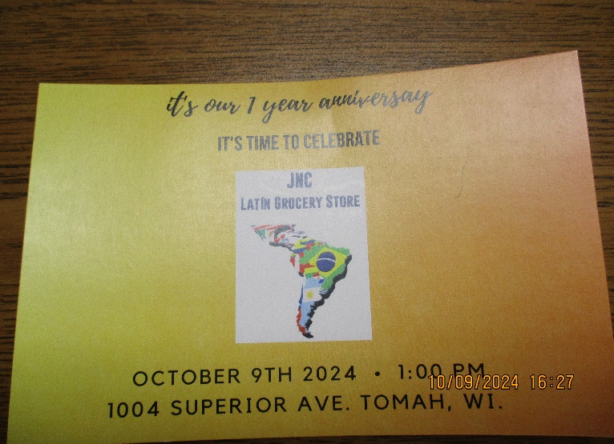 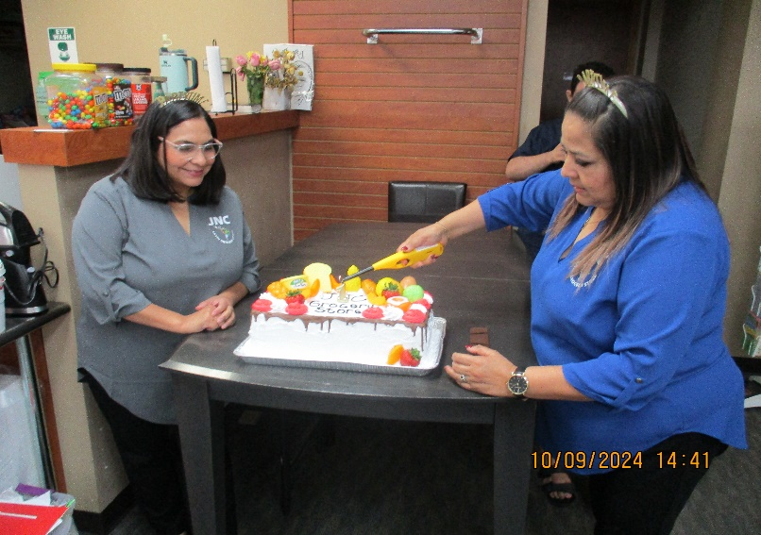  HAPPY First ANNIVERSARY to JNC Latin Grocery Store Here’s to many more! JNC Latin Grocery Store Owners Sisters Donaji Guzman Pulido & Georgina Guzman Gallegos Celebrating 1st Anniversary!  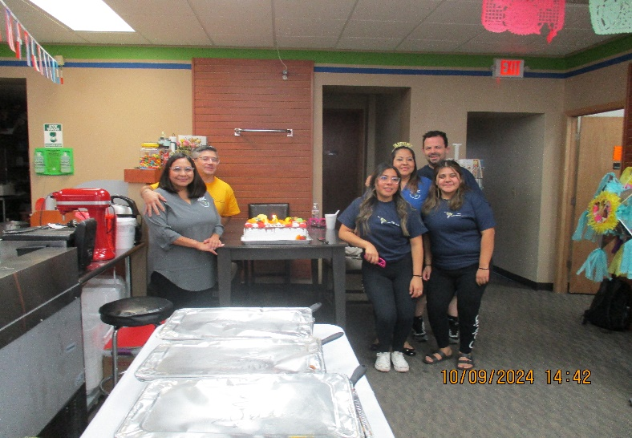 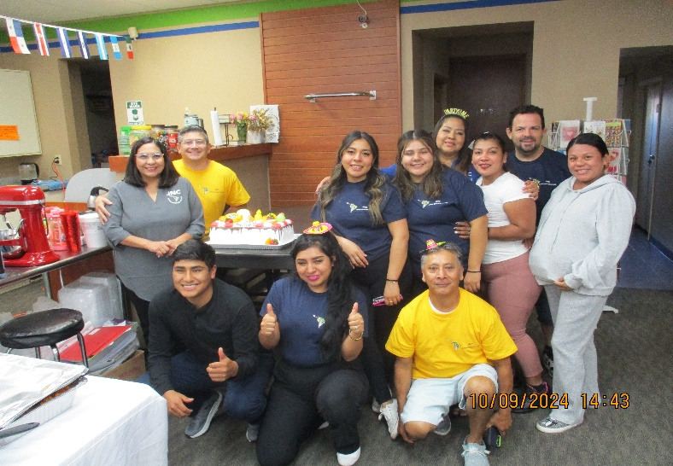  1st Anniversary celebration of JNC Grocery Store – there was lots of very good food, conversation, and laughter. Here’s to many more years! 1st Anniversary celebration of JNC Grocery Store next door to the senior center. We enjoy them there with easy access to the goodies. What a crew!  Page 02 |  | City of Tomah’s Dept. of SENIOR & DISABLED SERVICES 608-374-7476 Fax: 608-374-7462 pbuchda@tomahwi.gov Kupper-Ratsch Senior Center A Community Gathering Place 1002 Superior Ave. Tomah, WI. 54660 Facebook page – Tomah Senior Center  PHOTO ALBUM…Making Memories  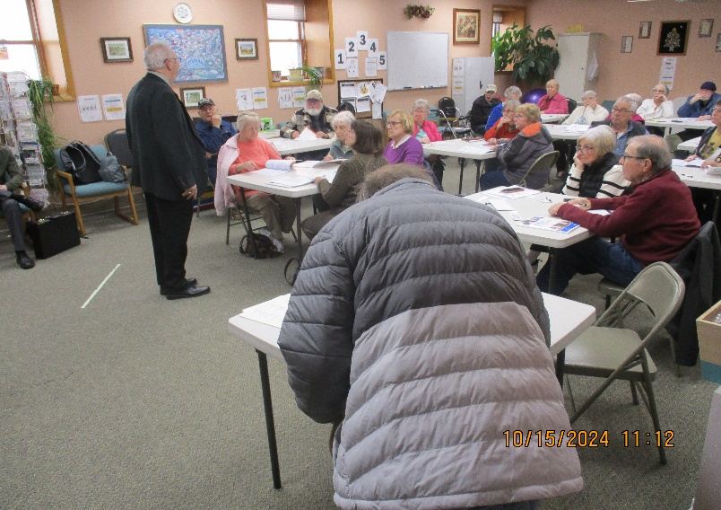 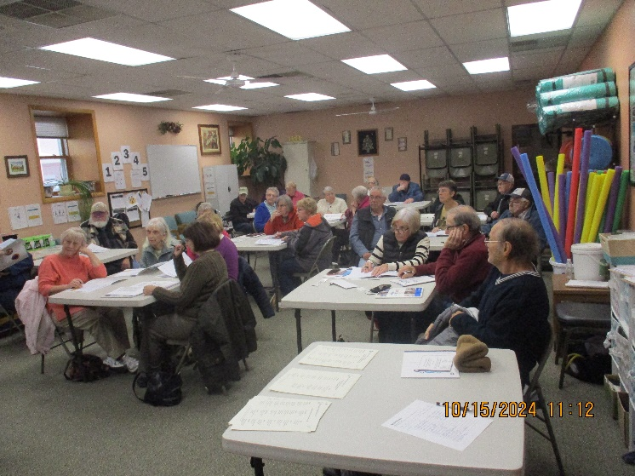  MEDICARE ADVANTAGE PLANS PRESENTATION by Harvey Lewis Insurance Agency Tuesday, October 15, 2024 MEDICARE ADVANTAGE PLANS PRESENTATION by Harvey Lewis Insurance Agency Tuesday, October 15, 2024  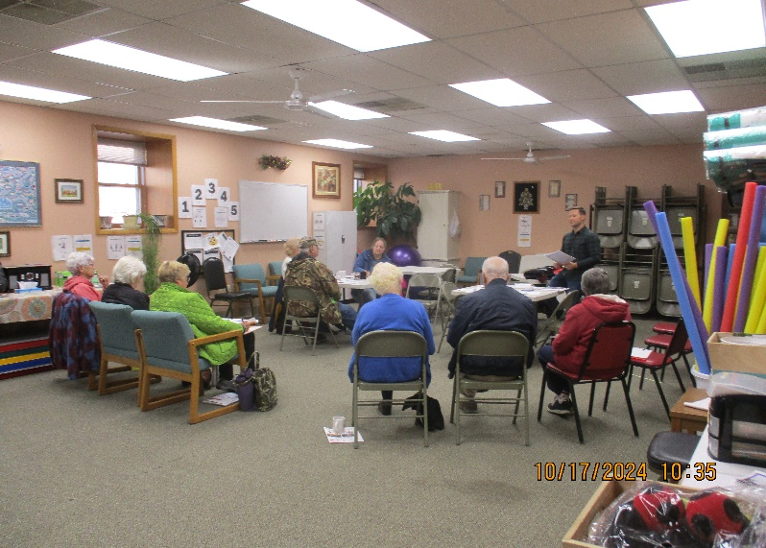 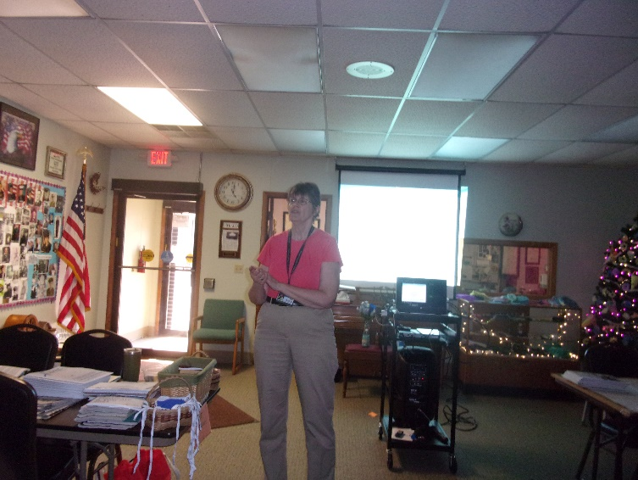  MEDICARE ADVANTAGE PLANS PRESENTATION by Jerry Tiffany Insurance Thursday, October 17, 2024 TAKE THE MYSTERY OUT OF MEDICARE PRESENTATION By Alice Ackerman, Elder Benefit Specialist of ADRC of Monroe County  In October we had quite a few Medicare Presentations:  - Alice Ackerman, ADRC of Monroe County Elder Benefit Specialist came to the senior center on: Tuesday, November 8 ‘Take the Mystery Out of Medicare’; ‘Medicare Advantage Plan Changes’ on Friday, November 18th, & Medicare Prescription Drug Plan Individual Assist on Wednesday, November 30.  -Two presentations on Tuesday, November 15 by Harvey Lewis Insurance Agency on Medicare Advantage Plans.  -Two presentations by Jerry Tiffany Insurance on Medicare Advantage Plans, one on the 17th & one on the 31st.  Page 03

